Pg.No: 74



Pg.No: 75











Pg.No:81



Pg.No:82









Pg.No:97





Pg.No:98



Pg.No:104









**Older Book:**







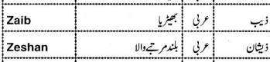

**Zohan/Zuhaan/Zehaan/Zeeshan**





















